Lakeshore Presbyterian Church
5235 Lakeshore Road
Fort Gratiot, MI 48059
810-385-4531
Pastor William Davis Pianist Lois Koon
Pastor Emeritus Diane Oswald Choir Director Phil Larson

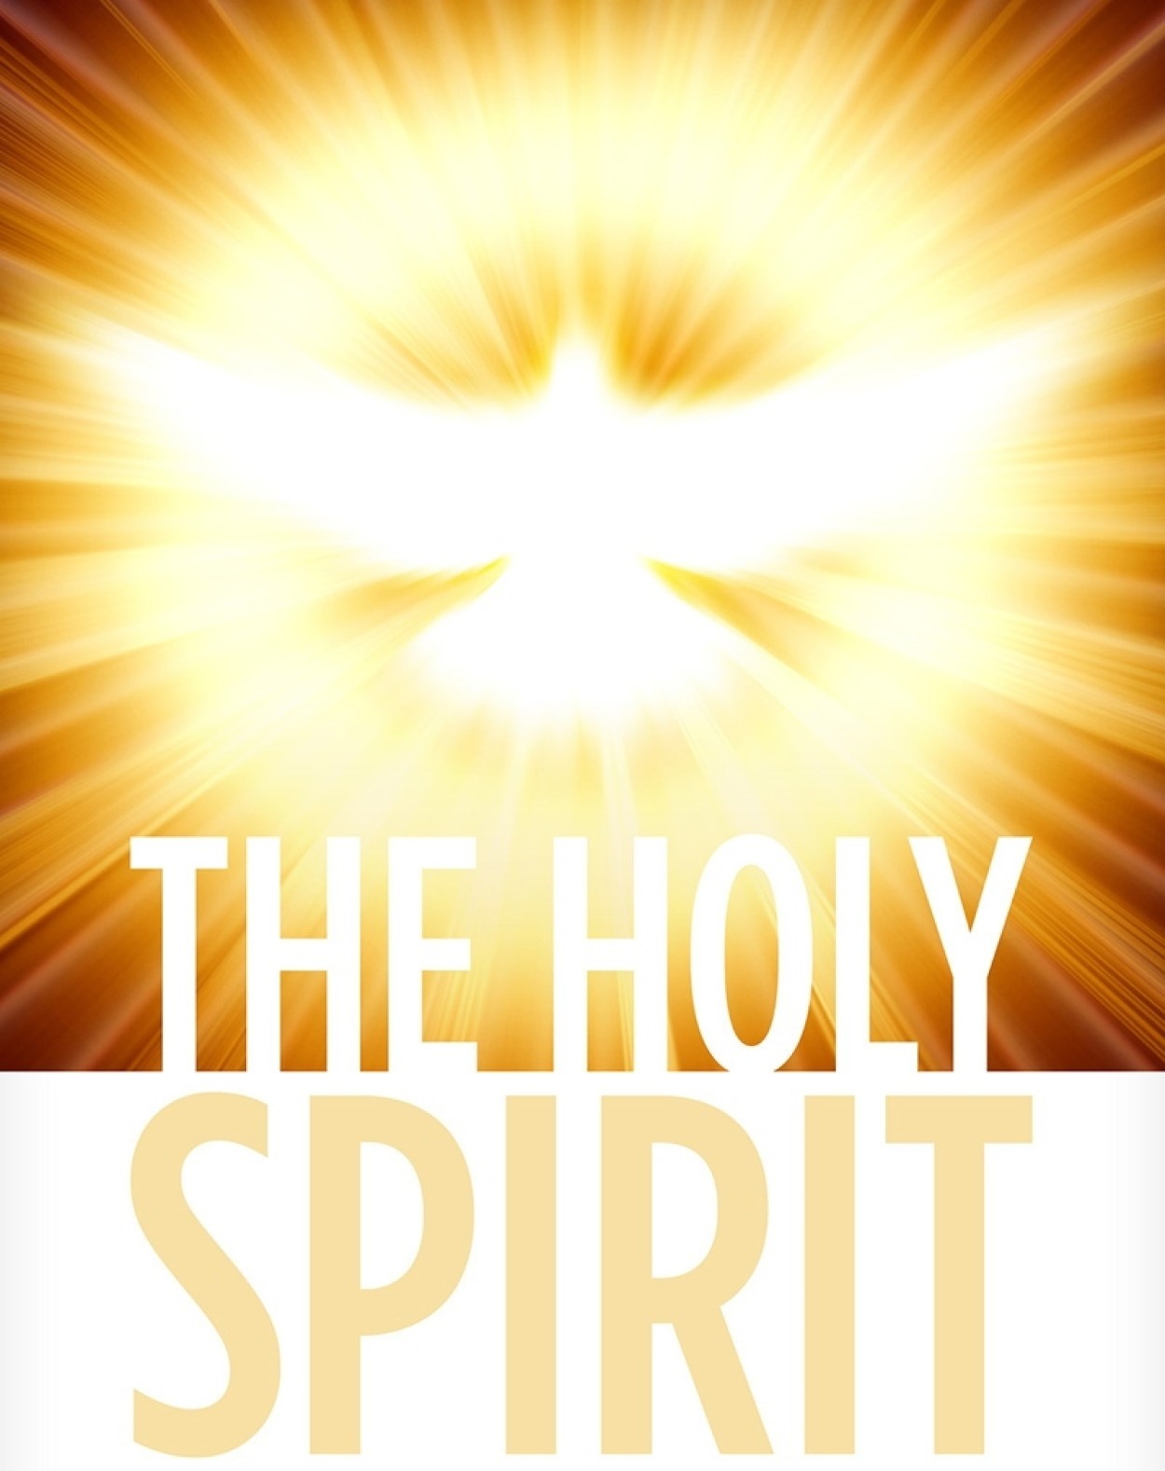
Lakeshore Presbyterian Church
October 25, 2026
Pastor Scott MacReady, presiding
Gary Baxter, Liturgist

WELCOME

CALL TO WORSHIP (Psalm 148:1-5)
One: Praise the Lord.
ALL: Praise the Lord from the heavens; praise him in the heights above.
One: Praise him, all his angels; praise him, all his heavenly hosts.
ALL: Praise him, sun and moon; praise him, all you shining stars.
One: Praise him, you highest heavens and you waters above the skies.
ALL: Let them praise the name of the Lord, for at his command they were created.
One: Let us continue to praise and worship the LORD our GOD!

PASSING OF THE PEACE
May the peace of Christ rule in your hearts.
The Lord be with you.
And also with you!
Let us greet one another with the peace of Christ.

Please stand if you are able
HYMN “Morning Has Broken” #469

PRAYER OF CONFESSION
I come to you LORD JESUS, Creator of the Universe. I ask your forgiveness for my sins, both known and unknown… Search my heart and see if there is anything, anything at all that keeps me from YOU… Create in me a clean heart O God and renew a steadfast spirit within me. Amen.
PERSONAL PRAYERS OF CONFESSION

ASSURANCE OF PARDON
One: Right now because of YOUR sacrifice, LORD JESUS:
ALL: I am forgiven right here and now! YOU are so kind and full of grace,
mercy and love. YOU love me just as I am. I thank YOU for making me part of YOUR family. Amen!

RESPONSE OF PRAISE Gloria Patri
Glory be to the Father, and to the Son, and to the Holy Ghost; as it was in the beginning, is now, and ever shall be, world without end. Amen. Amen.

CHOIR ANTHEM

PRAYER FOR ILLUMINATION

SCRIPTURES Deuteronomy 6:4-9
⁴ Hear, O Israel: The Lord our God, the Lord is one. ⁵ Love the Lord your God with all your heart and with all your soul and with all your strength. ⁶ These commandments that I give you today are to be on your hearts. ⁷ Impress them on your children. Talk about them when you sit at home and when you walk along the road, when you lie down and when you get up. ⁸ Tie them as symbols on your hands and bind them on your foreheads. ⁹ Write them on the doorframes of your houses and on your gates.

Matthew 22:34-40
³⁴ Hearing that Jesus had silenced the Sadducees, the Pharisees got together. ³⁵ One of them, an expert in the law, tested him with this question: ³⁶ “Teacher, which is the greatest commandment in the Law?”

³⁷ Jesus replied: “‘Love the Lord your God with all your heart and with all your soul and with all your mind.’³⁸ This is the first and greatest commandment. ³⁹ And the second is like it: ‘Love your neighbor as yourself.’ ⁴⁰ All the Law and the Prophets hang on these two commandments.”

SERMON “The Second Greatest Commandment”

Please stand if you are able
HYMN “There’s a Sweet, Sweet Spirit” #398

AFFIRMATION OF FAITH
Let us say what we believe:
I believe in God, the Father Almighty, maker of heaven and earth; And in Jesus Christ his only Son, our Lord; who was conceived by the Holy Ghost, born of the Virgin Mary, suffered under Pontius Pilate, was crucified, dead, and buried.

He descended into hell; On the third day he rose again from the dead; he ascended into heaven, and sitteth on the right hand of God the Father Almighty; from thence he shall come to judge the quick and the dead. I believe in the Holy Ghost, the holy catholic church, the communion of saints, the forgiveness of sins, the resurrection of the body, and the life everlasting. Amen.

SHARING OF JOYS, CONCERNS AND PRAYER REQUESTS

PASTORAL PRAYER

THE LORD’S PRAYER
Our Father, which art in heaven, hallowed be thy Name. Thy Kingdom come. Thy will be done on earth, as it is in heaven. Give us this day our daily bread. And forgive us our debts, as we forgive our debtors. And lead us not into temptation, but deliver us from evil. For thine is the kingdom, the power, and the glory, for ever and ever. Amen.

RESPONSE “Hear Our Prayer, O LORD”
Hear our prayer, O Lord
Hear our prayer, O Lord
Incline Thine ear to us
And grant us Thy peace

THE OFFERING

DOXOLOGY #592
Praise God from whom all blessings flow;
Praise Him all creatures here below
Praise Him above ye heavenly host;
Praise Father, Son, and Holy Ghost. Amen.

HYMN “Love Divine, All Loves Excelling” #376

CHARGE AND BENEDICTION

FELLOWSHIP

In Our Prayers  Roger Sheldon  Kate Phillips |   Marsha Larson
Sunday Mornings  9 – 9:45am  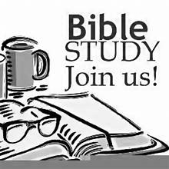 |  | 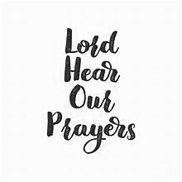  Group Prayer  Thursdays  10:30am
 |  |   11/4 4:00pm Deacons  11/5 11:00am E&O  11/10 10:00am Stewardship & Mgt  11/12 12:30pm Worship  1:30pm Session
  11/7 | 6pm | Concert
  11/11 | 4pm | Potluck
  11/14  11/14 | 1-3pm  3pm | Craft Day  Potato Bar

