Lakeshore Presbyterian Church
5235 Lakeshore Road
Fort Gratiot, MI 48059
810-385-4531
Pastor William Davis Pianist Lois Koon
Pastor Emeritus Diane Oswald Choir Director Phil Larson

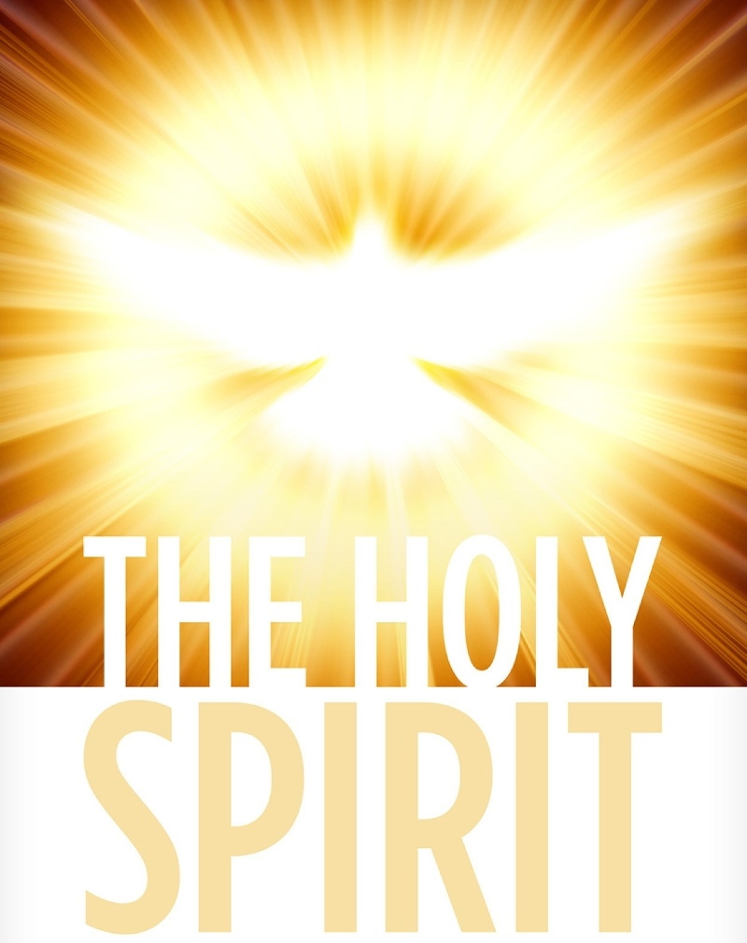
Lakeshore Presbyterian Church
October 11, 2026
Pastor Bill Davis, presiding

WELCOME

CALL TO WORSHIP (Ephesians 2:8-10)
One: For it is by grace you have been saved, through faith,
ALL: And this is not from yourselves, it is the gift of God,
One: Not by works, so that no one can boast.
ALL: For we are God’s handiwork, created in Christ Jesus to do good works, which God prepared in advance for us to do.
One: Let us worship the LORD our GOD!

PASSING OF THE PEACE
May the peace of Christ rule in your hearts.
The Lord be with you.
And also with you!
Let us greet one another with the peace of Christ.

Please stand if you are able
HYMN “Love Divine, All Loves Excelling” #376

PRAYER OF CONFESSION
Dear FATHER in Heaven, we admit that we are far from perfect. We confess that we are not in control of our emotions. We say things we later regret. We judge others. We don’t fully subject ourselves to YOUR loving care. Our faith falls short. We fear the future. We question our ability to handle the future. We seek YOUR forgiveness. We ask for YOUR mercy. We need YOUR grace. Amen!

PERSONAL PRAYERS OF CONFESSION

ASSURANCE OF PARDON

RESPONSE OF PRAISE Gloria Patri
Glory be to the Father, and to the Son, and to the Holy Ghost; as it was in the beginning, is now, and ever shall be, world without end. Amen. Amen.

CHOIR ANTHEM “Rock of Ages”

PRAYER FOR ILLUMINATION

SCRIPTURE Romans 3:21-26
²¹ But now apart from the law the righteousness of God has been made known, to which the Law and the Prophets testify. ²² This righteousness is given through faith in^{[a]} Jesus Christ to all who believe. There is no difference between Jew and Gentile, ²³ for all have sinned and fall short of the glory of God, ²⁴ and all are justified freely by his grace through the redemption that came by Christ Jesus. ²⁵ God presented Christ as a sacrifice of atonement,^{[b]} through the shedding of his blood—to be received by faith. He did this to demonstrate his righteousness, because in his forbearance he had left the sins committed beforehand unpunished— ²⁶ he did it to demonstrate his righteousness at the present time, so as to be just and the one who justifies those who have faith in Jesus.

SERMON “Grace Received”

Please stand if you are able
HYMN “How Firm a Foundation” #361

AFFIRMATION OF FAITH
Let us say what we believe:
I believe in God, the Father Almighty, maker of heaven and earth; And in Jesus Christ his only Son, our Lord; who was conceived by the Holy Ghost, born of the Virgin Mary, suffered under Pontius Pilate, was crucified, dead, and buried.

He descended into hell; On the third day he rose again from the dead; he ascended into heaven, and sitteth on the right hand of God the Father Almighty; from thence he shall come to judge the quick and the dead. I believe in the Holy Ghost, the holy catholic church, the communion of saints, the forgiveness of sins, the resurrection of the body, and the life everlasting. Amen.

SHARING OF JOYS, CONCERNS AND PRAYER REQUESTS

PASTORAL PRAYER

THE LORD’S PRAYER
Our Father, which art in heaven, hallowed be thy Name. Thy Kingdom come. Thy will be done on earth, as it is in heaven. Give us this day our daily bread. And forgive us our debts, as we forgive our debtors. And lead us not into temptation, but deliver us from evil. For thine is the kingdom, the power, and the glory, for ever and ever. Amen.

RESPONSE “Hear Our Prayer, O LORD”
Hear our prayer, O Lord
Hear our prayer, O Lord
Incline Thine ear to us
And grant us Thy peace

THE OFFERING

DOXOLOGY #592
Praise God from whom all blessings flow;
Praise Him all creatures here below
Praise Him above ye heavenly host;
Praise Father, Son, and Holy Ghost. Amen.

HYMN #What a Friend We Have In Jesus” #403

CHARGE AND BENEDICTION

FELLOWSHIP

In Our Prayers  Roger Sheldon  Kate Phillips | 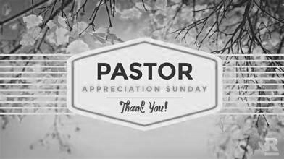
Sunday Mornings  9 – 9:45am  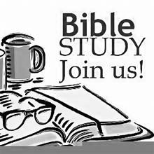 |  | 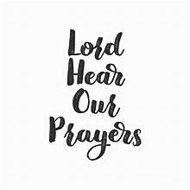  Group Prayer  Thursdays  10:30am
 |  |   Phil Larson
  Today | 11am | Pastor Appreciation Day
  10/14 | 4pm | Potluck
  10/22 | 11am-2pm | Senior Celebratipon

